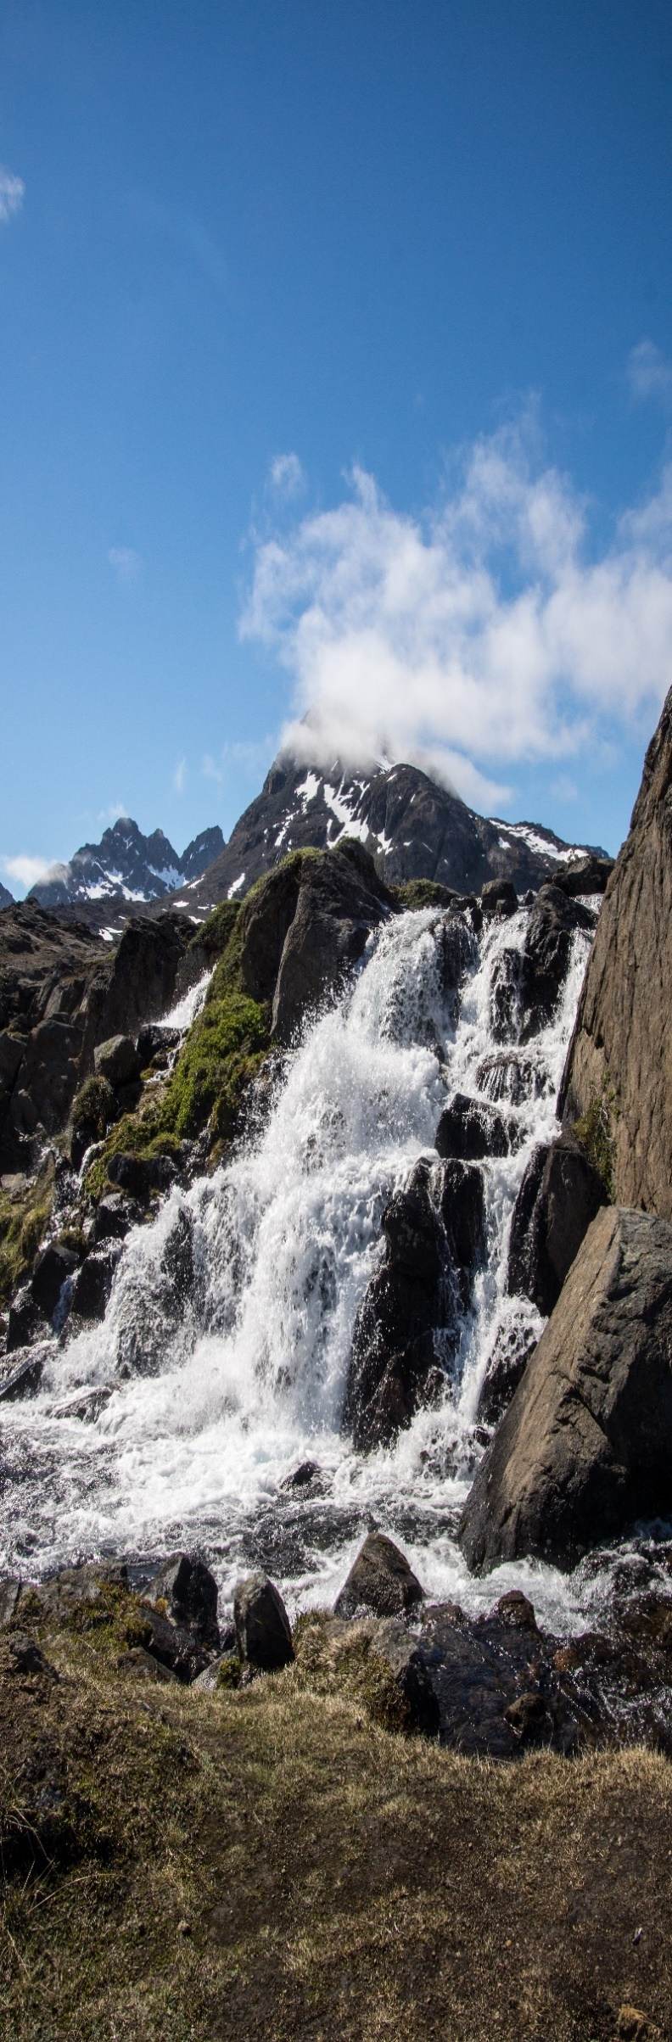
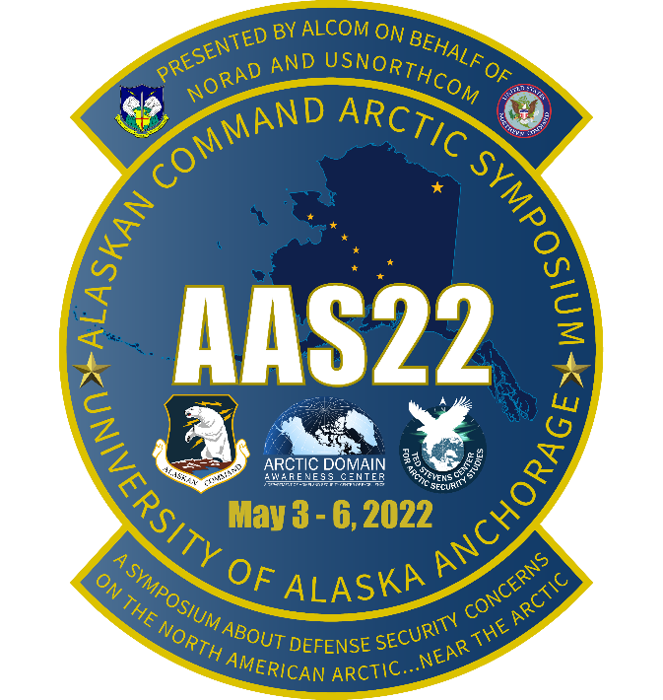

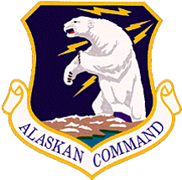

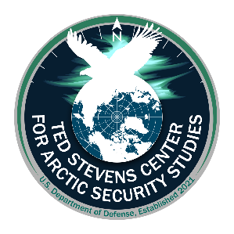

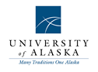

Presented on behalf of NORAD and USNORTHCOM

Alaskan Command Hosts
Arctic Symposium 2022
3 to 6 May 2022
Anchorage, Alaska

Symposium Program

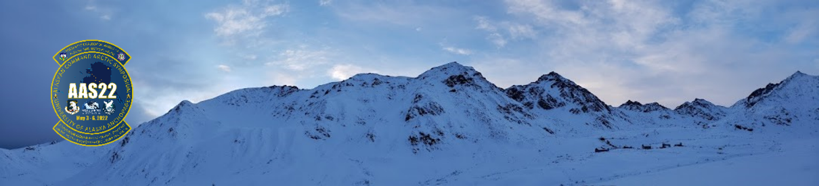
Introduction and Overview
In support of United States Northern Command (USNORTHCOM), Alaskan Command (ALCOM) (a subordinate unified command reporting to USNORTHCOM), located at Joint Base Elmendorf-Richardson (JBER) Alaska, is honored to host Arctic Symposium 2022 (AAS22) a symposium about the Arctic, conducted near the Arctic. ALCOM AAS22 is planned principally as an in-person event but will have a number of virtual participation options from 3-6 May in Anchorage Alaska.
Additionally, there will be two advance events hosted on Joint Base Elmendorf-Richardson (JBER) on 2 May. Accordingly, 2 May is considered AAS22 “Day Zero.”
Detailed planning, organizing, and support for ALCOM’s Arctic Symposium 2022 is provided by the Department of Defense’s newest Regional Center, the Ted Stevens Center for Arctic Security Studies, currently operating at JBER, and the Arctic Domain Awareness Center (ADAC), hosted at the University of Alaska Anchorage.
ALCOM’s Arctic Symposiums and Arctic Senior Leader Summits are provided in support of U.S. Northern Command (USNORTHCOM) and serve to help to fulfill ALCOM’s engagement-oriented tasks in association as the USNORTHCOM Lead for Arctic Affairs. AAS22 intentionally seeks to connect with two other events that are occurring during that same week in Alaska.
- ALCOM’s 75th Anniversary events scheduled on the afternoon and evening of 6 May, which will be held at JBER
- The second is the alignment of the Arctic Security Forces Roundtable, (ASFR) an international 2-star general/flag officer level event co-chaired by U.S. European Command (USEUCOM) and the Norwegian Defense staff, planned for 3-5 May in Fairbanks.
Arctic Symposium 2022 is planned as ALCOM’s signature Arctic convening/convergence event and will feature a wide variety of Arctic leaders and subject matter experts, focused on a broad range of Arctic security.
While the bulk of AAS22 is featured as in-person activity, remote participation for the Day 1 plenary, Day 2 virtual track, Day 3 VIP speakers and Day 4 morning sessions is planned for simultaneous virtual participation via Zoom.
Agenda times are presented in 24-hour clock style (not AM/PM) in two time zones: Alaska Daylight Time (AKDT) and Eastern Daylight Time (EDT).

ADAC at University of Alaska Anchorage hosts the current AAS22 information at: https://arcticdomainawarenesscenter.org/Events
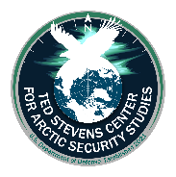
- The AAS22 “Event Hub” at the ADAC Website is the one stop shop for unclassified materials for the entire series of 2-6 May events.
- A complementary/duplicate set of AAS22 information will be available from a Stevens Center website once this site becomes available.
- As an extension of Chatham-House protocols, AAS22 is closed to the press and general public.
AAS22 Uniform/dress recommendations: Day 0 – 4 day dress code is Uniforms for military personnel is Utility clothing: OCP, Battledress, Flight Suit, etc. Civilian dress is business casual. Evening events is business casual. Note, specific clothing recommendations are needed for Day 2 Track 2 afternoon out of doors event.
AAS22 Production Company Assistance. Ted Stevens Center for Arctic Security Studies has secured “IMIG Audio Visual” in Anchorage as the AAS22 Production Assistance team to ensure the in-person and on-line aspects of AAS 22 is professionally and smoothly conducted. TSC is funding this additional aspect of the symposium. Please see: https://www.imigav.com/

Arctic Symposium 2022 Agenda
Monday, 2 May: AAS22 Day Zero – Catch-up and Classified Day
Two activities are planned as “Day Zero” for ALCOM’s Arctic Symposium 2022. One activity is geared for AAS22 participants who desire a strong background on the fundamentals of Arctic Security. Another activity is an invitation-only event for an Arctic Security classified tabletop exercise. Here are the associated details:
0900-1500 AKDT / 1300-1900 EDT: Arctic Region Security Orientation Course Executive Seminar (ARSOC-ES)
- A planned 5-6-hour Arctic region orientation geared for AAS22 attendees to provide an Arctic Security baseline.
- This unclassified course will be led and coordinated by the Ted Stevens Center for Arctic Security Studies.
- ARSOC-ES will be hybrid with in-person and virtual presentation via Zoom.
+++++++++++++++++++++++++++++++++++++++++++++++++++++++++++++++++++++++++++++
VIRTUAL CLASSROOM INFORMATION
https://alaska.zoom.us/j/88956878269?pwd=TmgxM0xQTzBjQzV0SURPWUN5TXBJUT09
Meeting ID: 889 5687 8269
Passcode: 376771
Dial by your location
+1 669 900 6833 US (San Jose)
+1 253 215 8782 US (Tacoma)
+1 346 248 7799 US (Houston)
+1 929 205 6099 US (New York)
+1 301 715 8592 US (Washington DC)
+1 312 626 6799 US (Chicago)
+++++++++++++++++++++++++++++++++++++++++++++++++++++++++++++++++++++++++++++

- ARSOC-ES sign up will be via AAS22 Registration.

1000-1500 AKDT / 1400-1900 EDT: ALCOM Classified Defense Tabletop Exercise.
- This invitation-only event requires advance presenting/coordination of security credentials.
- A planned 5-hour classified SECRET event with several separate exercise scenarios.
- USNORTHCOM J7 and ALCOM J5 are the planning lead for this event.
- Location for both activities: JBER Arctic Warrior Events Center (AWEC), 9387 Kuter Ave, JBER Alaska 99506.
Note: no evening events are planned for Day Zero.
Tuesday, 3 May: AAS22 Day 1 – Plenary Day
AAS22 opening day is planned to provide participants a broad survey of issues affecting or influencing the current Arctic security environment. Planned panels will provide both in-person and virtual presentations. Planned panels include:
- Location: Dena'ina Civic and Convention Center, 600 W 7th Ave, Anchorage, AK 99501
- Phone: (907) 263-2850
- Website: https://anchorageconventioncenters.com/denaina-center/overview
- Due to the uncertain nature of COVID19 protocols, panelists will include both in-person and virtual presentations via Zoom.gov
0700 AKDT / 1100 EDT
- Registration opens/check-in Dena’ina Center upstairs open lobby.
- Continental Breakfast is served.
0715 AKDT / 1115 EDT
- Virtual participation check in.
Conference call Zoom address https://us02web.zoom.us/j/88959280652?pwd=dWlGRmR6MFBPOE1pOEM2NUhpWEgvdz09
Meeting ID: 889 5928 0652
Passcode: 061221
One tap mobile
+13462487799,,88959280652#,,,,*061221# US (Houston)
+16699009128,,88959280652#,,,,*061221# US (San Jose)
Dial by your location
+1 346 248 7799 US (Houston)
+1 669 900 9128 US (San Jose
+1 253 215 8782 US (Tacoma
+1 312 626 6799 US (Chicago)
+1 646 558 8656 US (New York)
+1 301 715 8592 US (Washington DC)
Meeting ID: 889 5928 0652
Passcode: 061221
Find your local number: https://us02web.zoom.us/u/kdgXwHj2rP
0750 AKDT / 1150 EDT
- Participants to seats.
0800 AKDT / 1200 EDT: AAS22 Opening ceremonies.
- 0800 AKDT/1200 EDT: Official Party Enters
- Ruffles & Flourishes
- Honor Guard & Posting of the Colors
- National Anthem (SPC Trinity Colvin)
- Opening prayer (Chaplain, Capt. Kristina Norman)
- Lighting of a Ceremonial Seal Oil Lamp. Supported by Mr. Nagruk Harcharek, Ukpeaġvik Inupiat Cooperation, Utqiagvik, Alaska.
- Moment of silence for the conflict in Ukraine.
- Short introductory video provided by ADAC, University of Alaska
  - Link: https://youtu.be/dj2V0H469fQ
0810-0845 AKDT / 1210-1245 EDT: AAS22 Introduction and Welcome messages.
- Introductions: AAS22 Overall moderator TSC Senior Advisor for Arctic Security Affairs
- Welcoming remarks by:
  - Commander ANR, ALCOM, and 11 AF: Lt Gen David Krumm, USAF. (AAS 22 Host)
  - Lt Governor Kevin Meyer, State of Alaska. (Confirmed)
  - University of Alaska System/University of Anchorage leadership, welcome provided by UAA Chancellor Gov. Sean Parnell (Confirmed).
  - The Honorable Mayor Dave Bronson of the Municipality of Anchorage. (Confirmed)
  - Special Guest Appearance by Mrs. Catherine Stevens. (Confirmed)
0845 AKDT / 1245 EDT: AAS22 Participant Group Photos
- In-place photo of in-person participants and screen shots of on-line participants
0845-0945 AKDT / 1245-1345 EDT: Panel #1.
The emerging Arctic…security-trends from the view of 10,000 years.
A “fireside chat” with North American Arctic leaders to discuss the range of current security-related challenges and opportunities affecting Arctic residents. Speakers will address the current landscape of economic, environmental, and traditional security challenges regionally, from an Arctic “local and placed based” knowledge vantage.
Moderated by: Mr. Craig Fleener, Deputy Director, Ted Stevens Center for Arctic Security Studies. (Confirmed)
0945-1000 AKDT / 1345-1400 EDT: Break
1000-1100 AKDT / 1400-1500 EDT: Panel #2
The changing Arctic environment: Arctic research in support of DoD’s Arctic missions.
A panel of Arctic science experts will provide insight into their organization’s mission, capacities, capabilities, assets, and expertise that can support DoD-related needs and requirements to include domain awareness, impacts of climate change on infrastructure and operations, short and long-term planning objectives, and the ever-evolving need to identify and address DoD’s growing needs for the development, incorporation, and utilization of unique Arctic S&T throughout its broad range of mission sets.

Moderated by: Dr. Mike Sfraga, Chair, U.S. Arctic Research Commission, and Chair, Polar Institute, Woodrow Wilson Center for Scholars, Washington D.C. (Confirmed)
1100-1115 AKDT / 1500-1515 EDT: Break.
1115-1215 AKDT / 1515-1615 EDT: Panel #3
The changing Arctic economy what does the future hold?
A panel of experts addressing the factors of Arctic economy from resource extraction, initiatives to adapt to alternative economic measures, and relooking aspects of entrepreneurship. These experts will seek to describe current and developing efforts to access and develop the natural resources of the region, and the potential for economic progress within the Arctic.
Moderated by: Dr. Kathryn Friedman, Emeritus Professor, University at Buffalo, Global Fellow, Woodrow Wilson International Center for Scholars (Canada Institute). University at Buffalo, Buffalo, New York. (Confirmed)
1215-1315 AKDT / 1615-1715 EDT: Lunch Break, Dena'ina Civic and Convention Center.
1315-1415 AKDT / 1715-1815 EDT: Panel #4.
What are our strategic competitors up to…and how should we respond?
A panel of experts to highlight the respective Arctic oriented initiatives and activities of the Russian Federation and the People’s Republic of China from an unclassified viewpoint. Panelists will sketch the security challenges posed by U.S., Allied and Partner “strategic competitors” in the Arctic and outline approaches to cope/manage the problem.
Moderated by: RADM Matt Bell, USCG (Ret), Dean, School of Arctic and Climate Security Studies, Ted Stevens Center for Arctic Security Studies Affiliate, Kodiak, Alaska. (Confirmed)
1415-1430 AKDT / 1815-1830 EDT: Break.

1430-1515 AKDT / 1830-1915 EDT: Panel #5.
Who else is trying to become an Arctic player…and why?
A panel of experts describe the emerging Arctic interests and associated initiatives from an Indo-Pacific and European national vantage. As a complement and contrast from the prior session, this panel seeks to sketch the current and emerging interests of the non-Arctic nations and significant organizations within those regions in the Indo Pacific, Asian and European theaters to the region from a political, environmental and economic vantage point.
Moderated by: Maj Gen (Ret), Church Kee, USAF, Ted Stevens Center for Arctic Security Studies (Confirmed)
1515-1600 AKDT / 1915-2000 EDT: Panel #6.
The closing of the Arctic frontier…every acre is claimed…now what?
A panel of experts analyze the myriad of national claims in and across the Arctic basin and seek to foresight what may happen following the adjudication of claims, particularly with regard to extended continental shelf regions.
Moderated by: Dr. Kathryn Friedman, Emeritus Professor, University at Buffalo, Global Fellow, Woodrow Wilson International Center for Scholars (Canada Institute). University at Buffalo, Buffalo, New York. (Confirmed)
1600-1615 AKDT / 2000-2015 EDT: Break
1615-1700 AKDT / 2015-2100 EDT: Panel #7
The wired Arctic…assessing the impacts of new commercial investments in communications and situational awareness technologies across the pan-Arctic.
Experts provide a survey of recent technology advances based on commercial investments in ground-based fiber and polar orbiting satellite networks.
Moderated by: Brig Gen (Ret) Dieter Bareihs, ACT-1 Contract Manager, Ted Stevens Center, Crystal City Virginia. (Confirmed)
1700-1710 AKDT / 2100-2110 EDT: Wrap up and closing remarks
  - Commander, ANR, ALCOM, and 11 AF
  - Information update by AAS22 overall coordinator.
1830-2030 AKDT: AAS22 Welcoming reception – Sullivan’s Steakhouse
  - 320 W 5th Ave, Anchorage, AK 99501.
  - Beverages and buffet style heavy hors d'oeuvres.
  - Alaska Native Dance group: King Island Dancers Associated URL is https://www.facebook.com/KingIslandDancers
  - Associated URL: https://www.sullivanssteakhouse.com/anchorage/

Wednesday, 4 May: AAS22 Day 2 – Choose Your Adventure Day
AAS22 Day 2 starts with a planned set of morning tracks, which participants select in advance via the AAS22 Registration Site. Following a scheduled lunch, the afternoon provides a scheduled set of tour experiences for participants as well an optional outdoor hike for those who do not wish to participate in the tours.
- Note, participants need to provide gear for the hike (footwear and inclement weather/protective clothing).
- A scheduled participant meal following the afternoon activities will provide further networking opportunities.
Location: Dena'ina Civic and Convention Center, 600 W 7th Ave, Anchorage
0700 AKDT / 1100 EDT
  - Registration opens/check in Dena’ina Center upstairs open lobby.
  - Continental Breakfast is served.
0715 AKDT / 1115 EDT
  - Virtual participation check in.
Conference call Zoom address
https://us02web.zoom.us/j/88959280652?pwd=dWlGRmR6MFBPOE1pOEM2NUhpWEgvdz09
Meeting ID: 889 5928 0652
Passcode: 061221
One tap mobile
+13462487799,,88959280652#,,,,*061221# US (Houston)
+16699009128,,88959280652#,,,,*061221# US (San Jose)
Dial by your location
+1 346 248 7799 US (Houston)
+1 669 900 9128 US (San Jose
+1 253 215 8782 US (Tacoma
+1 312 626 6799 US (Chicago)
+1 646 558 8656 US (New York)
+1 301 715 8592 US (Washington DC)
Meeting ID: 889 5928 0652
Passcode: 061221
Find your local number: https://us02web.zoom.us/u/kdgXwHj2rP
0750 AKDT / 1150 EDT
  - Participants to Seats in plenary session.

0800-0810 AKDT / 1200-1210 EDT: Welcome back and brief overview of AAS22 Day 2 AM and PM Tracks
The AM tracks include the following:
  - Track 1: Arctic Crisis Response Tabletop Exercise (TTX). Led by Ted Stevens Center for Arctic Security Studies contracted entities, the Arctic crisis TTX is intended to provide participants an experience in addressing the dynamics in crisis response actions and activities.
  - Track 2: Arctic Academic and Industry Showcase. Via a moderated activity, this combined track of academic and industry presenters provides Arctic Symposium 2022 participants a current snapshot of on-going activities and new initiatives that advance science, safety and/or security for the Arctic region.
AAS22 in-person participants will be provided the following set of options for activities for afternoon adventures. Note, the afternoon tracks are only available to in-person participation.
  - Alaskan Security Orientation Activities: This starts with a flight line orientation of 11th Air Force Airpower, followed by a visit to Anchorage Museum, and Port of Alaska visits.
  - Guided afternoon hike in the Eagle River Nature Center. Out of doors gear is required and must be user-furnished. Note, this is primarily hiking boots, socks, and layers composed of synthetic materials. The wear of cotton materials is strongly discouraged.
0810-0820 AKDT / 1210-1220 EDT
  - Participants move to their respective tracks.
0820-1200 AKDT / 1220-1600 EDT (with scheduled breaks organized within each track).
- AAS22 “Choose your adventure, morning edition”
  - AAS22 Day 2 Morning Edition Adventure Track 1: Unclassified Arctic Crisis Tabletop Exercise. A guided 3 move tabletop exercise where the participants form the planning and decision team to think through the challenges of assessing each fictitious situation, determining priorities, planning and creating a framework of response.
Moderators: Maj Gen (Ret) Randy “Church” Kee, USAF, Ted Stevens Center, Anchorage Alaska. and Dr. Mike Sfraga, Chair, Polar Institute, Woodrow Wilson Center and Chair, U.S. Arctic Research Commission, Washington, D.C. (Confirmed)
Exercise moves.
  - 0820-0930 AKDT / 1220-1330 EDT: “Attu Re-imagined.” A fictitious crisis scenario which challenges sovereignty, security and environmental policies and the ability to logistically respond to the farthest west U.S. island in the Aleutian chain.
    - 0945-1045 AKDT / 1335-1445 EDT: “Bounty in the Beaufort.” A fictitious crisis scenario that exposes the friction points related to the United Nations Convention of the Law of the Sea in managing a commercial venture in contested waters in the Extended Economic Zone between Canada and the U.S. in the Beaufort Sea.

    - 1100-1200 AKDT / 1500-1600 EDT: “Trapped at the North Pole.” A fictitious crisis scenario of an exploratory venture of commercial icebreaker escorting a merchant breakbulk vessel transiting the transpolar route that encounters a significant powerplant failure rendering both vessels trapped in more significant than planned ice conditions in the vicinity of the North Pole.
  - AAS22 Morning Edition Adventure Track 2: Arctic Academic and Industry Showcase. Conducted as a series of information briefs from Arctic-oriented academics and industry collaborators.
Conference call Zoom address
https://us02web.zoom.us/j/5548082846pwd=Z1o4NVBwbXFxWElQb2FCcDErUGlWZz09
Meeting ID: 554 808 2846
Passcode: 638605
One tap mobile
+13462487799,,5548082846#,,,,*638605# US (Houston)
+16699009128,,5548082846#,,,,*638605# US (San Jose)
Dial by your location
+1 346 248 7799 US (Houston)
+1 669 900 9128 US (San Jose)
+1 253 215 8782 US (Tacoma)
+1 312 626 6799 US (Chicago)
+1 646 558 8656 US (New York
+1 301 715 8592 US (Washington DC)
Meeting ID: 554 808 2846
Passcode: 638605
Find your local number: https://us02web.zoom.us/u/kdLbCVbCXc

Co-Moderated by: RADM (Ret) Matt Bell, USCG, Dean, School of Arctic and Climate Security Studies, Ted Stevens Center for Arctic Security Studies, Alaska and Dr. Kathrynn Friedman, Emeritus Professor, University at Buffalo, Global Fellow, Woodrow Wilson International Center for Scholars (Canada Institute). University at Buffalo, Buffalo, New York. (Confirmed)
    - 0820-0835 AKDT/1220-1235 EDT: Women Peace and Security…insights for the Arctic.
      - Ms. Veronica Clark, Alaskan Command, JBER, Alaska (Confirmed)
      - Ms. Claire D. Sneed, Women, Peace, and Security Advisor, NORAD & USNORTHCOM (Confirmed/Virtual)
      - Ms. Tiffani Phillips the N&NC Command Gender Advisor (Virtual/Pending)
      - Dr. Holly Peirce, our N&NC Deputy POLAD (Confirmed)
    - 0835-0850 AKDT / 1235-1250 EDT: eLORAN for the Arctic…an alternative for positioning, navigation and timing? Mr. Trowbridge "Bridge" Littleton, President & Co-Founder, Hellon Systems, Inc., Middleburg, Virginia. https://hellensystems.com/ (Confirmed, Virtual)
    - 0850-0920 AKDT / 1250-1310 EDT: Diversity in Arctic Research…Projecting the Future? Dr. Victoria Herrmann, White House Fellow on assignment to HQ U.S. Coast Guard, Washington D.C. and Dr. Elizabeth Buchanan, Head of Research for the Royal Australian Navy, Canberra, Australia. (Confirmed/Virtual)
    - 0920-0940 AKDT / 1310-1340 EDT: Research insights to Arctic Pollution Response. Dr. Nancy Kinner, University of New Hampshire and (research leader, Arctic Domain Awareness Center (ADAC), University of Alaska), Duram, New Hampshire. https://www.arcticdomainawarenesscenter.org/ (Confirmed)
    - 0940-1000 AKDT / 1340-1400 EDT: Understanding Arctic Environmental Change through the parameters of a decision risk index. Dr. Craig Tweedie, University of Texas El Paso (and research leader, ADAC, University of Alaska), El Paso Texas. https://www.arcticdomainawarenesscenter.org/ (Confirmed)
    - 1000-1015 AKDT / 1400-1415 EDT: Break.
    - 1015-1035 AKDT / 1415-1430 EDT: Successfully succeeding the Navy Arctic Research Laboratory: Ukpeaġvik Inupiat Corporation-Science. An overview of UIC-Science endeavors to support exercises and research, including U.S. Navy’s icepack activities known as “ICEX.” Mr. Nagruk Harcharek, Director of Barrow Operations, UIC, Anchorage, Alaska. https://uicalaska.com/our-companies/uic-commercial-services/uic-science-llc/ (Confirmed)
    - 1030-1120 AKDT / 1430-1520 EDT: Alaska: future outlook as America’s Arctic Research Laboratory. A survey of current research and initiatives from the UAF Geophysical Institute and International Arctic Research Center. Dr. Bob McCoy and Dr. Hajo Eicken, UAF, Fairbanks, Alaska. https://www.gi.alaska.edu/ and https://uaf-iarc.org/ (Dr. McCoy, confirmed, Dr. Eicken Confirmed).
  - 1120-1140 AKDT / 1520-1540 EDT: The Future of Fish in the Arctic? A quick look at the evolving characteristics of fisheries of the Bering Sea. Mr. Taylor Holshouser, Managing Director, Alaska Ocean Cluster, Bering Sea Fishermen’s Association, Anchorage, Alaska. https://www.bsfaak.org/. (Confirmed)
  - 1140-1200 AKDT / 1540-1600 EDT: Maslow’s hierarchy in an Arctic context? A quick look at solutions to improve water and sanitation in rural regions of Alaska’s Arctic. Dr. Aaron Dotson, Vice Chancellor for Research, University of Alaska Anchorage, Anchorage Alaska. https://www.alaska.edu/orgcharts/uaa/vc-research/index.php . (Confirmed)

1200-1300 AKDT: Lunch. Location: Dena'ina Civic and Convention Center.
1300-1700 AKDT: Choose your adventure afternoon session. Note: transportation for both tracks depart from streetside of Dena'ina Civic and Convention Center.
- AAS22 “Choose your adventure, afternoon edition options”
  - AAS22 Day 2 Afternoon Edition Adventure Track 1. Alaskan Security Orientation Activities. This starts with a flight line orientation of 11th Air Force Airpower, followed by a visit to the Port of Alaska and Anchorage Museum.
    - Overall Guides, Maj Gen (Ret) Church Kee and Mr. Craig Fleener, Ted Stevens Center.

  - AAS22 Day 2 Afternoon Edition Adventure Track 2. Guided afternoon hike in the Eagle River Nature Center.
    - User-furnished out of doors gear (primarily hiking boots, socks, and layers composed of synthetic materials) is required. The wear of cotton materials is strongly discouraged.
    - Overall guides are CDR Frank “BIFF” McBride and Mr. Shane Holtz, ALCOM J5.
1800-2030 AKDT: AAS22 Day 2 Dinner, Heritage Theater room at 49th State Brewery, 717 W 3rd Ave, Anchorage, AK 99501 URL: https://www.49statebrewing.com/
- AAS22 Day 2 Dinner Guest presentation: AAS22 Day 2 Dinner Guest presentation: “A conversation in advancing Arctic Diplomacy” Planned: Mr. Jim DeHart, Senior Arctic Coordinator, Department of State, Washington D.C., with Dr. Mike Sfraga, Chair, U.S. Arctic Research Commission and Chairman, Polar Institute, Woodrow Wilson Center for Scholars, Washington D.C. (Confirmed)
Thursday, 5 May: AAS22 Day 3 – Leaders Forum and Strategic Foresight Day
AAS22 Day 3 is planned in 2 major components, the first activity will be an introduction to a hands-on Arctic Security Strategic Foresight exercise oriented to Arctic conditions in the year 2060. Following the futures exercise, the afternoon will comprise of a listen and learn session from an array of Distinguished Leaders in their views broadly relating to Arctic Safety, Security and Defense. The day will conclude with an evening event. Day 3 VIP presentations is planned to be simulcast for on-line participants.
Location: Dena'ina Civic and Convention Center, 600 W 7th Ave, Anchorage, AK 99501
0700 AKDT / 1100 EDT
- Registration opens/check in Dena’ina Center upstairs open lobby.
- Continental Breakfast is served.
0715 AKDT / 1115 EDT
- Virtual participation check in.
Conference call Zoom address https://us02web.zoom.us/j/88959280652?pwd=dWlGRmR6MFBPOE1pOEM2NUhpWEgvdz09
Meeting ID: 889 5928 0652
Passcode: 061221
One tap mobile
+13462487799,,88959280652#,,,,*061221# US (Houston)
+16699009128,,88959280652#,,,,*061221# US (San Jose)
Dial by your location
+1 346 248 7799 US (Houston)
+1 669 900 9128 US (San Jose
+1 253 215 8782 US (Tacoma
+1 312 626 6799 US (Chicago)
+1 646 558 8656 US (New York)
+1 301 715 8592 US (Washington DC)
Meeting ID: 889 5928 0652
Passcode: 061221
Find your local number: https://us02web.zoom.us/u/kdgXwHj2rP
0750 AKDT / 1150 EDT
- Participants to Seats in plenary session.
0800-0810 AKDT / 1200-1210 EDT: Welcome back and brief overview of AAS22 Day 3
0810-0825 AKDT / 1210-1225 EDT: Overview of Strategic Foresight Activity, targeting the Arctic Region Challenges in the Year 2060.
- Led by USCG HQ U.S. Coast Guard, Office of Emerging Policy (DCO-X) “Project Evergreen/Futures” team, Washington, D.C. (Confirmed).
0825-0930 AKDT / 1225-1330 EDT: Strategic Foresight Exercise Activity.
0930-0945 AKDT / 1330-1345 EDT: Break.
0945-1010 AKDT / 1345-1410 EDT: AAS 22 ALCOM, ANR and 11 AF Commander Address. Lt Gen David Krumm, USAF, Commander, ALCOM, ANR and 11 AF.
1010-1015 AKDT / 1410-1415 EDT: Introduction of 1st Keynote address – Lt Gen David Krumm, USAF, Commander, ANR, ALCOM, and 11 AF. (Confirmed)
1015-1045 AKDT / 1415-1445 EDT: AAS 22 Keynote Address: Arctic Now – Insights from the Commander, NORAD and USNORTHCOM. General Glen VanHerck, USAF (Confirmed).
1045-1100AKDT/1445-1500: Break
1100-1145 AKDT/1500-1545 EDT: AAS 22 Alaska Officials Address: State of the Arctic from the State of Alaska Viewpoint.
Moderated by Dr. Mike Sfraga, Chair, U.S. Arctic Research Commission, and Chair, Wilson Center Polar Institute.
1145-1245 AKDT / 1545-1645 EDT: Arctic Region Political Leaders:
A reflection of what is working vs what is missing in considering overall security in the North American Arctic.
Moderated by: Mr. Craig Fleener, Ted Stevens Center.
1245-1330 AKDT / 1645-1730 EDT: Lunch. Location: Dena'ina Civic and Convention Center.
1330-1400 AKDT / 1730-1800 EDT: AAS 22 Keynote address: Arctic Climate Security: Crisis, Concern or…? Planned Speaker: Deputy Assistant Secretary of Commerce for International Fisheries, Dr. Kelly Kryc, with introduction by Col (Ret) John Murphy, Chief of Operations, National Weather Service, Washington, D.C. (Confirmed)
1405-1435 AKDT / 1730-1830 EDT: AAS Keynote address: The Arctic and Strategic Deterrence: essential for America and Allied/partner security. Admiral Charles “Chas” Richard, USN, Commander, United States Strategic Command. (Confirmed)
1430-1545 AKDT / 1830-1945 EDT: Reflections from the International Arctic Security Forces Roundtable.
Moderated By: Brig Gen (Ret) Dieter Bareihs, ACT-1 Contract Manager, Ted Stevens Center for Arctic Security Studies, Crystal City Virginia. (Confirmed)
Chaired by:
- Commodore Solveig Krey, Chief of Staff Operations, Defense Staff, Norway (Confirmed)
- Brig Gen Edward “Hertz” Vaughan, USAF, Deputy Director Plans, Strategy and Policies (J5) U.S. European Command, Stuttgart, Germany. (Confirmed).
1545-1600 AKDT / 1945-2000 EDT: Break.
1600-1630 AKDT /2000-2030 EDT: AAS Keynote conversation: ANSCA at 50+, Past, Present and Future. Mr. Emil Notti with Mr. Nagruk Harcharek (Confirmed)
  - Mr. Notti was a founding collaborator of ANSCA and the original President of Alaska Federation of Natives
  - Mr. Harcharek is a member of Ukpeaġvik Inupiat Corporation (UIC), Utqiagvik, Alaska.
1630-1650 AKDT/2030-2050 EDT: AAS Keynote conversation. Arctic Perspectives from a Command Chief Vantage. David Wolfe, Command Chief Master Sergeant, USAF, Pacific Air Forces and Kristopher Berg, Command Chief Master Sergeant, USAF, Eleventh Air Force, moderated by Dr Mike Sfraga, Chair, Wilson Center Polar Institute and U.S. Arctic Research Commission. (Confirmed).
1650-1655 AKDT / 2050-2055 EDT: Wrap up and closing remarks by Commander, ANR, ALCOM, and 11 AF, with information update by AAS22 overall coordinator.
1800-2030 AKDT: AAS22 Day 3 Dinner, Alaska Heritage Aviation Museum 4721 Aircraft Dr, Anchorage, AK 99502, with Marx Brothers Catering from 6:00-8:30 PM URL: Alaska Aviation Air Museum Anchorage - Alaska Aviation Museum - Anchorage (alaskaairmuseum.org)
Planned Dinner Guest Speaker: A conversation on Arctic Maritime Security. Admiral Jamie Foggo, USN (Ret), Former Commander, U.S. Naval Forces Europe, who now resides in Alexandria Virginia, moderated by CDR Rachel Gosnell, USN (Confirmed)
Friday, 6 May: AAS22 Day 4 – “Broadening Arctic Horizons Day”
AAS22 Day 4 will start with an address by the U.S. Congressional members with keen Arctic interests and includes an interactive convergence event of available participants returning from the U.S. European Command (USEUCOM)-Norwegian Defense Staff Co-hosted Arctic Security Forces Roundtable (ASFR) which is planned for Fairbanks from 3-5 May 2022. Following, will be the closing session of AAS22, an ALCOM Former Commander’ event, oriented for their respective future insights based on past experiences. Ranging from geopolitical to environmental/climate security challenges, these former ALCOM Commanders (who also served as Commanders of Alaskan NORAD Region and 11th Air Force) will seek to synthesize risks, opportunities and recommendations to prepare, plan and operate to meet the challenges of the near to mid-term Arctic. Commander ALCOM, ANR and 11th Air Force will then provide final reflections and bring the session to a close.
Day 4 is planned to be simulcast for on-line participants. Location: Dena'ina Civic and Convention Center, 600 W 7th Ave, Anchorage, 99501
0700 AKDT / 1100 EDT
  - Registration opens/check in Dena’ina Center upstairs open lobby (details TBA).
  - Continental Breakfast is served.
0715 AKDT / 1115 EDT
  - Virtual participation check in.
Conference call Zoom address
https://us02web.zoom.us/j/88959280652?pwd=dWlGRmR6MFBPOE1pOEM2NUhpWEgvdz09
Meeting ID: 889 5928 0652
Passcode: 061221
One tap mobile
+13462487799,,88959280652#,,,,*061221# US (Houston)
+16699009128,,88959280652#,,,,*061221# US (San Jose)
Dial by your location
+1 346 248 7799 US (Houston)
+1 669 900 9128 US (San Jose
+1 253 215 8782 US (Tacoma
+1 312 626 6799 US (Chicago)
+1 646 558 8656 US (New York)
+1 301 715 8592 US (Washington DC)
Meeting ID: 889 5928 0652
Passcode: 061221
Find your local number: https://us02web.zoom.us/u/kdgXwHj2rP
0750 AKDT / 1150 EDT
  - Participants to Seats in plenary session.
0800-0805 AKDT / 1200-1205 EDT: Welcome back and brief overview of AAS22 Day 4

0805-0820 AKDT/1205-1220 EDT: Update from the Arctic Executive Steering Committee. Reflections provided by Ambassador David Balton, Executive Director, Arctic Executive Steering Committee, Office of Science and Technology Policy, Executive Office of the President, Washington D.C via virtual presentation. (Confirmed/Virtual)

0820-0900 AKDT / 1220-1300 EDT: Arctic 2022: The View from Congress: an “in-sequence” set of reflections from U.S. Congressional members with significant and consequential Arctic interests.
Note: with Congress in session, the Congressional presentations are planned as live stream.
Moderated by: Mr. Craig Fleener, Ted Stevens Center. (Confirmed)
0900-0945 AKDT / 1300-1345 EDT: AAS22 North American Defense & Security Policy Leaders Chat. A policy level focused discussion from a North American senior defense and security leader’s vantage.
Moderated by: Maj Gen (Ret) Randy “Church” Kee, USAF, Ted Stevens Center for Arctic Security Studies, Anchorage, Alaska.
0945-1000 AKDT / 1345-1400 EST: Break
1000-1100 AKDT / 1400-1500 EDT: Arctic Security 2022 convergence and contrasts by Defense Practitioners. A General/Flag and Senior Officer U.S. and international allies and Partners panel from a pan-Arctic viewpoint, as a complement to Arctic Security Forces Roundtable as previously discussed.
Moderated by: RADM (Ret) Matt Bell, USCG, Dean, School of Arctic and Climate Security Studies, Ted Stevens Center for Arctic Security Studies. (Confirmed)
1100-1140 AKDT / 1500-1540 EDT: Insights from the National Guard Arctic Interest Council. A closing panel from participating delegations of the Arctic Interest Council of the National Guard.
1140-1150 AKDT / 1540-1550 EDT: Closing reflections –Commander, Alaska NORAD Region, Alaskan Command, and 11th Air Force, Lt Gen David Krumm, USAF.
1150 AKDT / 1550 EDT: End of Conference.
1200-1300 AKDT / 1600-1700 EDT: AAS22 Planners/Support remain available to assist, collect feedback, etc.
Note: Polling results will be included with the subsequent AAS22 report.

Administrative details
Moderation/facilitation and recording: AAS22 planners will provide moderation of all sessions, recorded by dedicated personnel. Note, permissions are included in the registration, and any/all reports will be used via Chatham House protocols.
Post Summit Executive Summary and Report: AAS22 planners will provide a timely report summarizing key presentations, discussions, and conclusions. The scope of the summary will at minimum include: the date and location of the event, event agenda, major themes and messages, and scope of participants.
AAS22 Host Facility: Dena’ina Center, 600 W. Seventh Avenue · Anchorage, AK 99501.
URL: https://anchorageconventioncenters.com/denaina-center/overview
AAS22 Transportation (busses), is provided by Alaska Premier Tours.
URL: https://premieralaskatours.com
AAS 22 Hotels: Symposium Hotel blocks and/or discounted rates at
- Hotel Captain Cook, 939 W 5th Ave, Anchorage, AK 99501. URL: https://captaincook.com/
- Springhill Suites, 4050 University Lake Dr, Anchorage, Alaska 99508. URL: https://www.reservations.com/Hotel/springhill-suites-anchorage-university-lake
Weather Information (All Temps are in Fahrenheit)
  - Mon 2 May: Cloudy, H: 51 L: 39
  - Tue 3 May: Cloudy, H:54 L:39
  - Wed 4 May: Mostly Cloudy, H:53, L:38
  - Thu 5 May: Mostly Cloudy, H: 54 L:38
  - Fri 6 May: Mostly Cloudy, H: 55 L:39
Conclusion
AAS22 will improve participants’ understanding of the challenges in the complicated risk environment that describes the new circumpolar north. This will be accomplished via a series of thoughtful discussions and activities to gain insights for needed solutions to address and potentially reduce the associated defense and security risks. AAS22 will continue the momentum started with AMS18 and advanced through ASLS19, AAS19, and ASLS21, setting the stage for the fall 2022 Arctic Senior Leader Summit.

Post Event Opportunity
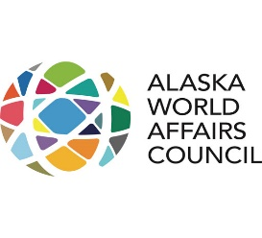
Follow on event (Immediately following the close of AAS22:
Brought to you by Alaska World Affairs Council: The Future of Cybersecurity: Ensuring Security and Building Resilience | Panel Discussion

Please see: https://www.alaskaworldaffairs.org/events/the-future-of-cybersecurity-ensuring-security-and-building-resilience-panel-discussion/
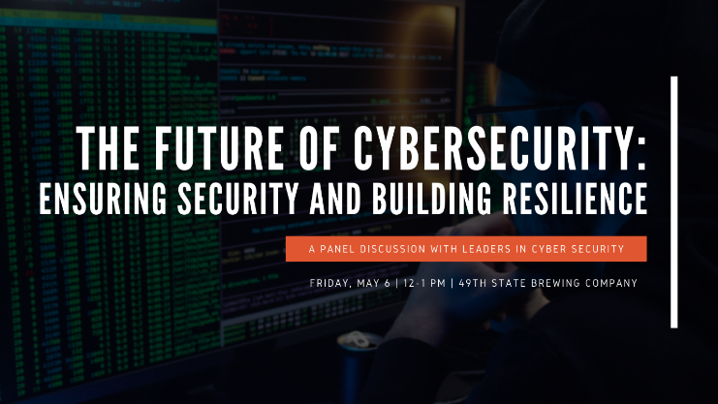
Date/Time
Date(s) - Friday, May 6, 2022
12:00 pm - 1:00 pm
Location
49th State Brewing Company

https://www.eucom.mil/pressrelease/41236/military-leaders-address-collective-arctic-security-issues
https://www.eucom.mil/pressrelease/41873/useucom-norway-staff-talks-bolster-mutual-readiness

